

Python Assignment

# Date: 28/08/2020

## Answer the Questions

### What are the key features of Python?

1. What type of language is python? Programming or scripting?
2. How is Python an interpreted language?
3. Is Indentation required in Python? What is Indentation?
4. How do you write comments in Python? What are the different types of comments? And how to implement them. Show with examples.
5. Differentiate between Compiler and Interpreter.
6. What are Python Variables? Show with an example.

## Solve the given Programs

1. Write a Python program to print "Hello Python".

Output-

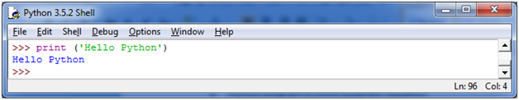

### 

1. Write a Python Program to add two numbers.

Input- 4, 5

Output- 9

1. Write a Python Program to subtract two numbers.

Input- 15, 5

Output- 10

1. Write a Python Program to multiply two numbers.

Input- 12, 6

Output- 72

1. Write a Python Program to divide two numbers, and find both dividend and remainder.

Input- 24, 2

Output- 12, 0

Use Algorithm-

1. Write a Python Program to find the area of the triangle.
2. Write a Python Program to find the perimeter of the square.
3. Write a Python Program to find the perimeter of the square.
4. Write a Python Program to find the average of any 5 numbers.

page break

1) There are many features in Python, some of which are discussed below –

**1. Easy to code:**  
Python is a high-level programming language. Python is very easy to learn the language as compared to other languages like C, C#, Javascript, Java, etc. It is very easy to code in python language and anybody can learn python basics in a few hours or days. It is also a developer-friendly language.

**2. Free and Open Source:**  
Python language is freely available at the official website and you can download it from the given download link below click on the **Download Python** keyword.  
[Download Python](https://www.python.org/downloads/)  
Since it is open-source, this means that source code is also available to the public. So you can download it as, use it as well as share it.

**3. Object-Oriented Language:**  
One of the key features of python is Object-Oriented programming. Python supports object-oriented language and concepts of classes, objects encapsulation, etc.

**4. GUI Programming Support:**  
Graphical User interfaces can be made using a module such as PyQt5, PyQt4, wxPython, or Tk in python.  
PyQt5 is the most popular option for creating graphical apps with Python.

**5. High-Level Language:**  
Python is a high-level language. When we write programs in python, we do not need to remember the system architecture, nor do we need to manage the memory.

**6. Extensible feature:**  
Python is a **Extensible** language. We can write us some Python code into C or C++ language and also we can compile that code in C/C++ language.

**7. Python is Portable language:**  
Python language is also a portable language. For example, if we have python code for windows and if we want to run this code on other platforms such as Linux, Unix, and Mac then we do not need to change it, we can run this code on any platform.

**8. Python is Integrated language:**  
Python is also an Integrated language because we can easily integrated python with other languages like c, c++, etc.

**9. Interpreted Language:**  
Python is an Interpreted Language because Python code is executed line by line at a time. like other languages C, C++, Java, etc. there is no need to compile python code this makes it easier to debug our code. The source code of python is converted into an immediate form called **bytecode**.

**10. Large Standard Library**  
Python has a large standard library which provides a rich set of module and functions so you do not have to write your own code for every single thing. There are many libraries present in python for such as regular expressions, unit-testing, web browsers, etc.

**11. Dynamically Typed Language:**  
Python is a dynamically-typed language. That means the type (for example- int, double, long, etc.) for a variable is decided at run time not in advance because of this feature we don’t need to specify the type of variable.

2) Yes, Python is a scripting language. It is also an interpreted and **high-level programming language** for the purpose of general programming requirements.

3) **Python is** called an **interpreted language** because it goes through an **interpreter**, which turns code you write into the **language** understood by your computer's processor.

4) Yes. To indicate a block of code in **Python**, you must **indent** each line of the block by the same whitespace. It is **required** for indicating what block of code a statement belongs to. ... So, **Python** code structures by **indentation**.

5) A comment, in general, is an expression of one’s ideas. In programming, comments are programmer-coherent statements, that describe what a block of code means. They get very useful when you are writing large codes. It’s practically inhuman to remember the names of every variable when you have a hundred-page program or so. Therefore, making use of comments will make it very easy for you, or someone else to read as well as modify the code.

Comments can be included anywhere which means inline as well. The best practice is to write relevant comments as and how you proceed with your code.

 Here are some key points that will help you while commenting your code:

* Comments need to be short and relevant
* They are to be specific to the block of code they are included with
* Make sure to use decent language, as using foul language is unethical
* Don’t comment self-explanatory lines

## ****Types of Comments****

[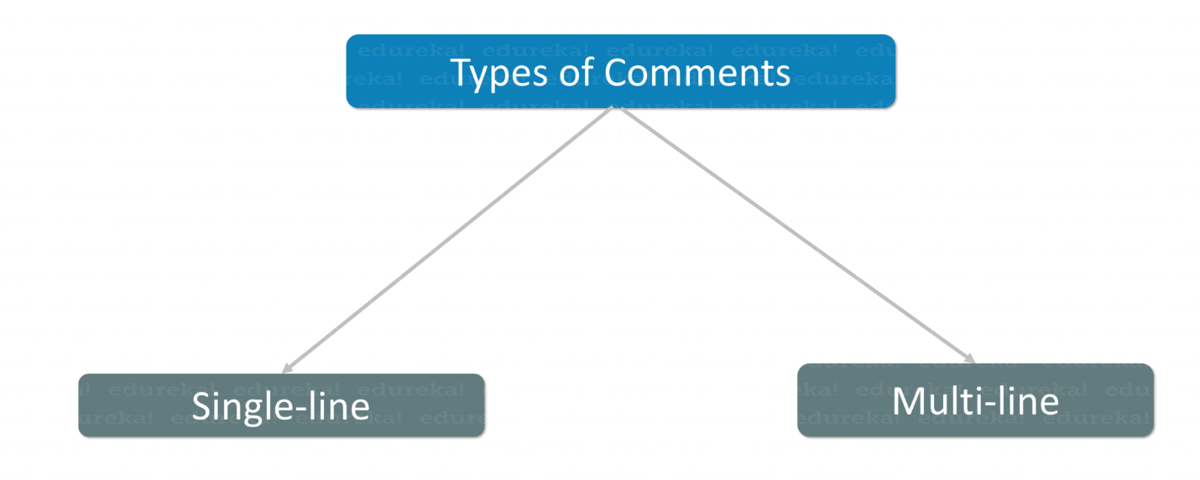](https://www.edureka.co/blog/content/ver.1556012641/uploads/2019/04/Types-of-Comments-Comments-in-Python-Edureka-2.png)Comments can either be

* Single-line or
* Multi-line

### **Single-line Comments:**

They can appear either in an individual line or inline with some other code.

**Example:**

|  |  |
| --- | --- |
| 1  2  3  4  5 | #multiplying two variables          (this line starts with a #, hence will be ignored till line ends)  a=1  b=2  c=a*b  print(c)     # printing result      (inline comment, whatever is present after # will be ignored) |

**Output:** 2

### **Multi-line Comments:**

Multi-line comments appear in more than one line. All the lines to be commented are to be prefixed by a #. If you don’t do so, you will encounter an error.

**Example:**

|  |  |
| --- | --- |
| 1  2  3  4  5  6 | #adding 2 variables  #pinting the result in a new variable  a=2  b=3  c=a+b  print(c) |

**Output:**5

6) **Compiler** transforms code written in a high-level programming language into the machine code, at once, before program runs, whereas an **Interpreter** coverts each high-level program statement, one by one, into the machine code, during program run. Compiled code runs faster while interpreted code runs slower.

7) Variables are nothing but reserved memory locations to store values. This means that when you create a variable you reserve some space in memory.

Based on the data type of a variable, the interpreter allocates memory and decides what can be stored in the reserved memory. Therefore, by assigning different data types to variables, you can store integers, decimals or characters in these variables.

Example:

counter = 100 # An integer assignment

miles = 1000.0 # A floating point

name = "John" # A string

print counter

print miles

print name